**Chadron WMA – March 5, 2020**

|  |  |
| --- | --- |
| 42 40'46.78"N | 102 59'56.83"W |

Placed new logger at culvert, north side of road (at gate). Logger is on west bank roughly 10 feet from opening of culvert. Placed in the pool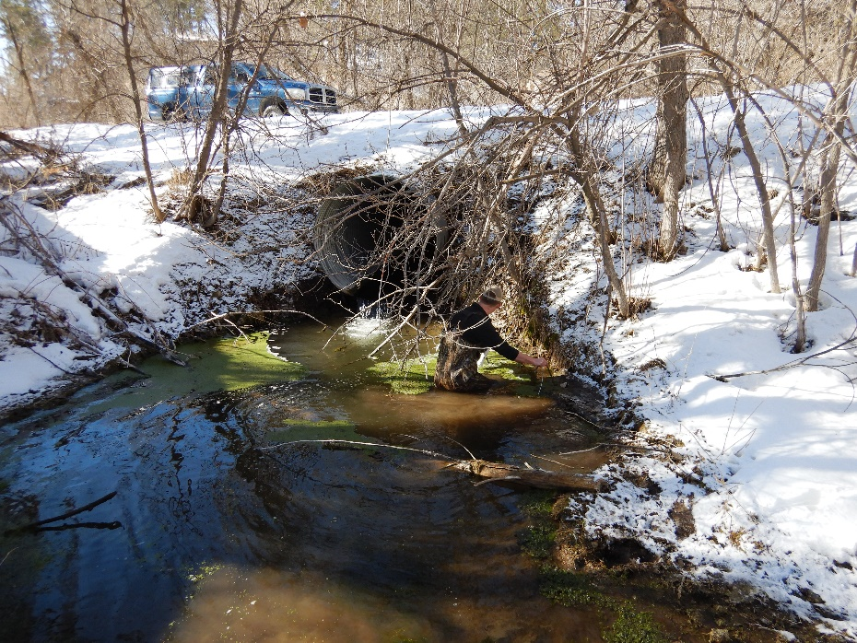

**Chadron entrance – replaced logger March 5, 2020**

|  |  |
| --- | --- |
| 42°42'28.10"N | 103° 00'27.50"W |

Could not find, placed new logger on T post in cattails. 10 feet from bridge, center of bridge opening.

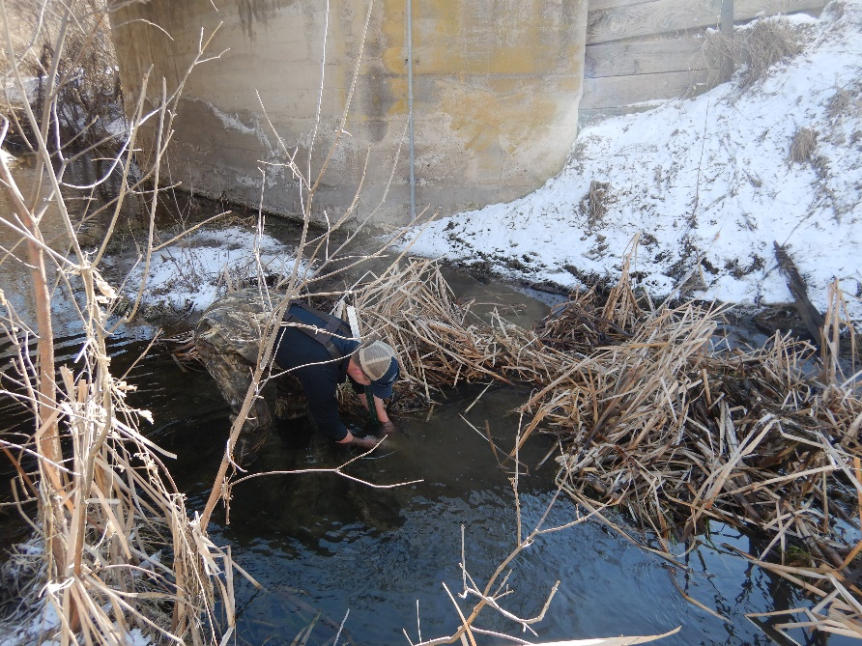

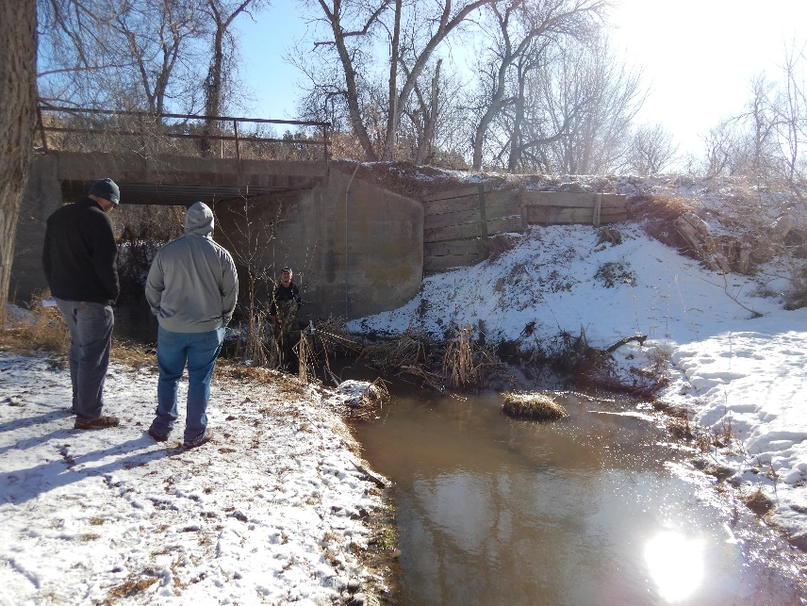

**Chadron Park exit – found! Downloaded March 5, 2020**

|  |  |
| --- | --- |
| 42°42'58.45"N | 103° 0'44.01"W |

Reset in same location 5 feet from fence east side of creek, algae covered. Single rebar post pressed through pvc pipe.

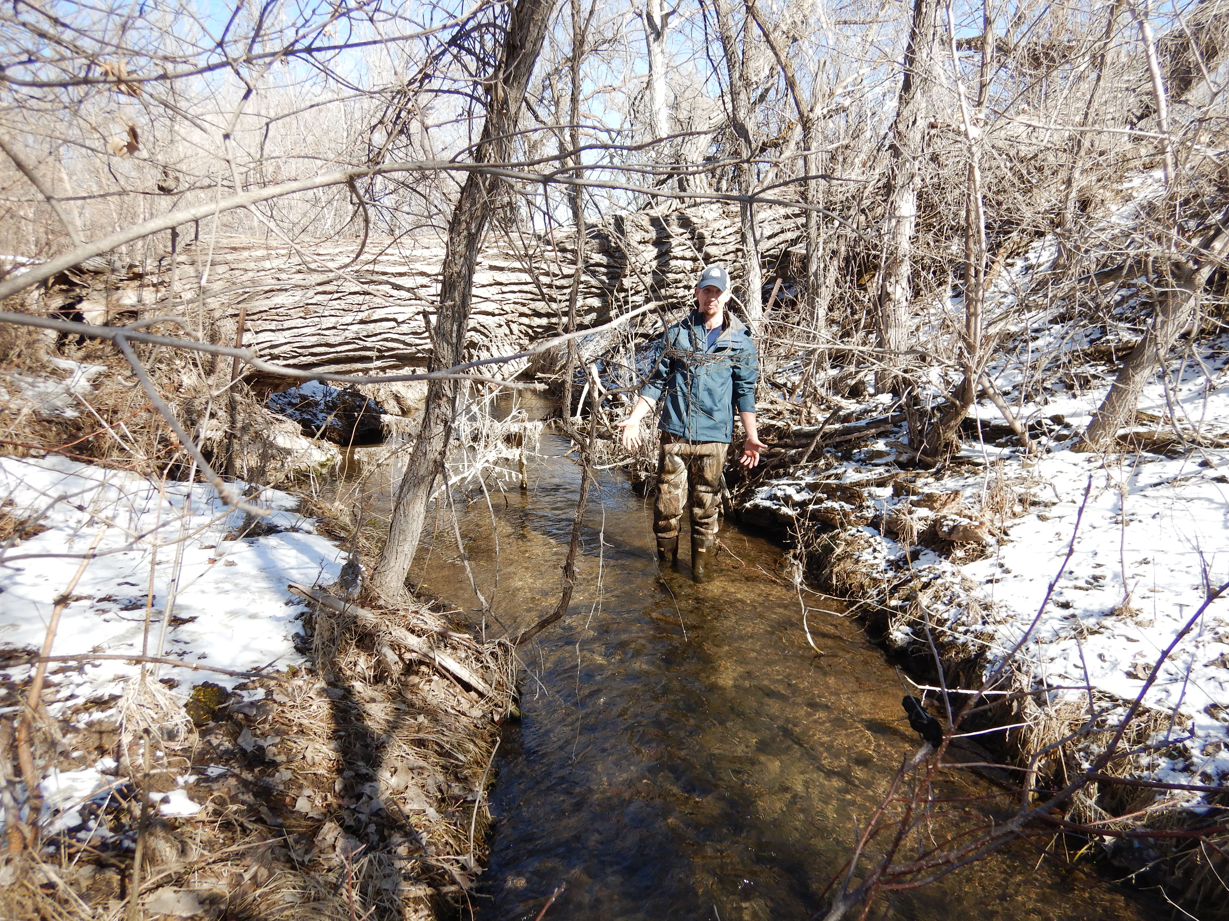

**East Ash Creek – found and downloaded, March 5, 2020**

|  |  |
| --- | --- |
| 42°37'25.43"N | 103°11'20.78"W |

Reset in same location. Green T-post on NW bank

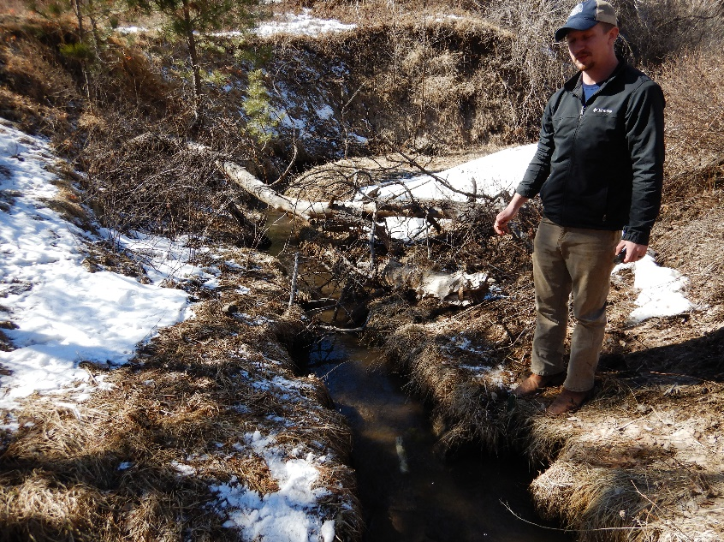

**West ash Creek – replaced where logger once was (2016), March 5, 2020**

|  |  |
| --- | --- |
| 42°37'45.14"N | 103°14'50.23"W |

Green t post

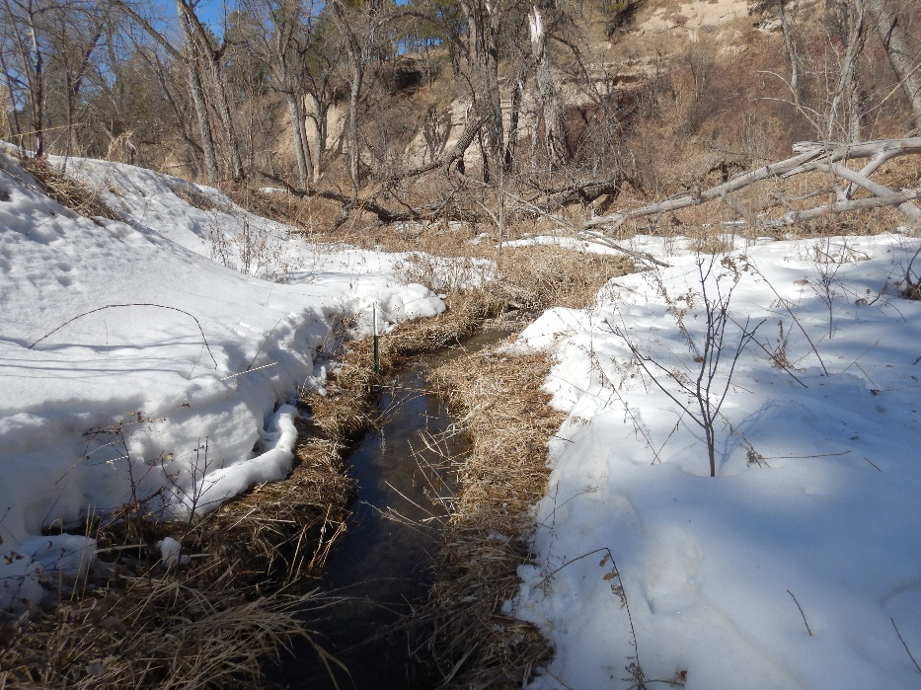

**9 mile WMA – lost old logger, reset new logger on March 11, 2020**

|  |  |
| --- | --- |
| 41°53'18.9"N | 103°26'02.10"W |

3rd vortex structure upstream of bridge west side under a rock rebar post in bank

**9 mile OFW – reset on March 11, 2020**

|  |  |
| --- | --- |
| 41°52'24.70"N | 103°26'13.00"W |

Attached to Southern most bridge IBeam on West bank, Wrapped around beam and attached using carabineer.

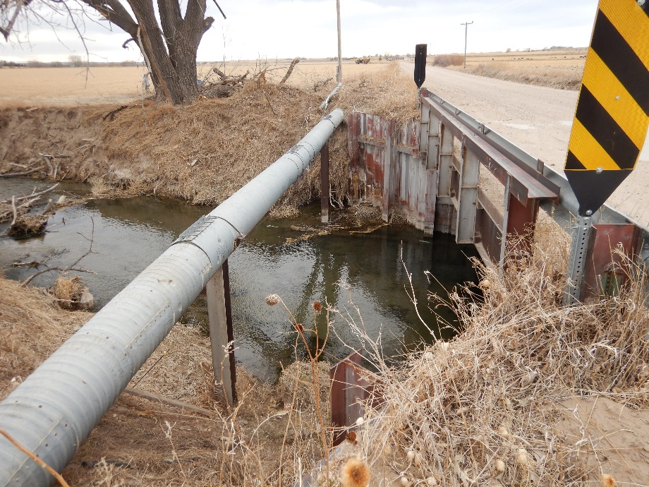

**Dry Spotted Tail – lost old logger, replaced with a new logger March 11, 2020**

|  |  |
| --- | --- |
| 41°56'33.60"N | 103°49'59.3"W |

Wrapped around height gauge meter under bridge and attached using carabineer.

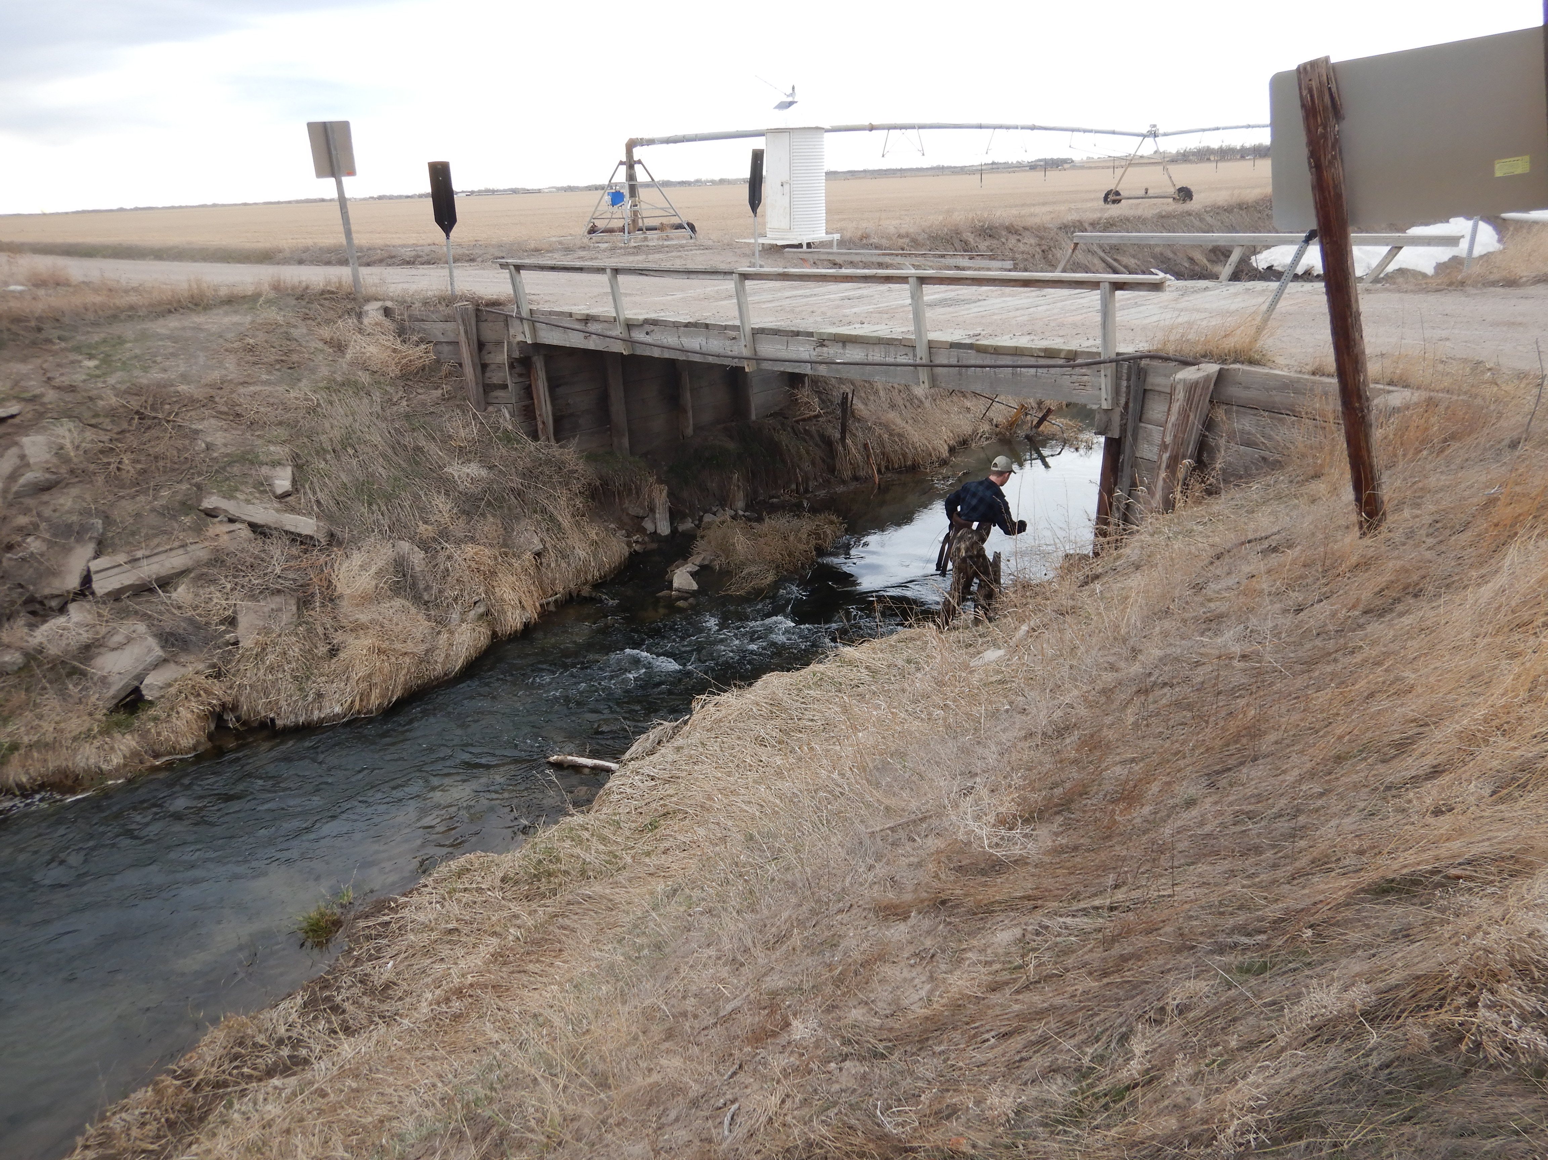

**Sheep Creek 2 – lost, replaced with a new logger on March 11, 2020**

|  |  |
| --- | --- |
| 42° 2'56.00"N | 104° 01'43.7"W |

Attached to green T-post on east side of stream, just downstream of tree overhanging the water

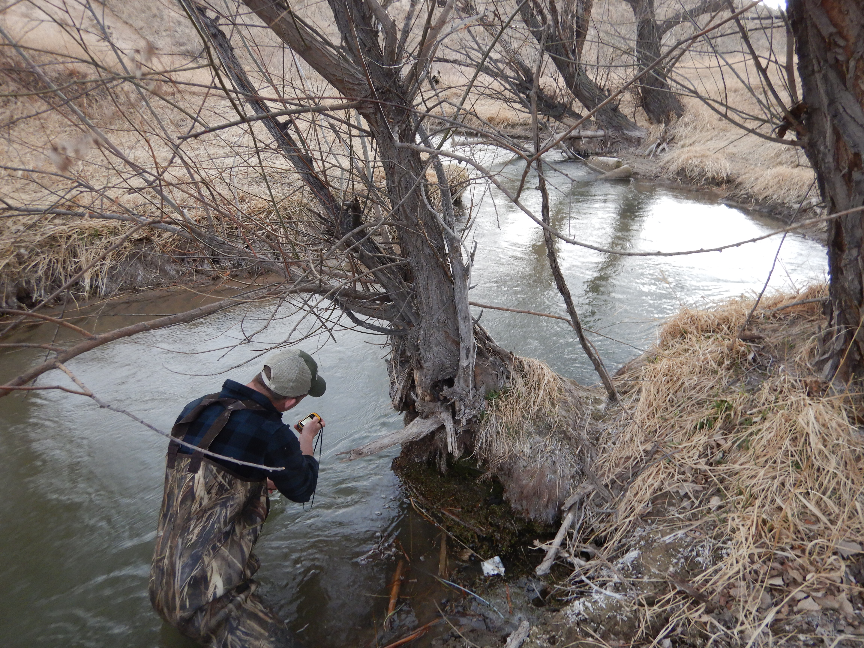

**Sheep Creek 1 – lost replace new logger March 11, 2020**

|  |  |
| --- | --- |
| 42°16'15.00"N | 104° 2'57.4"W |

Staked down in middle of the stream 10 ft up stream of spring

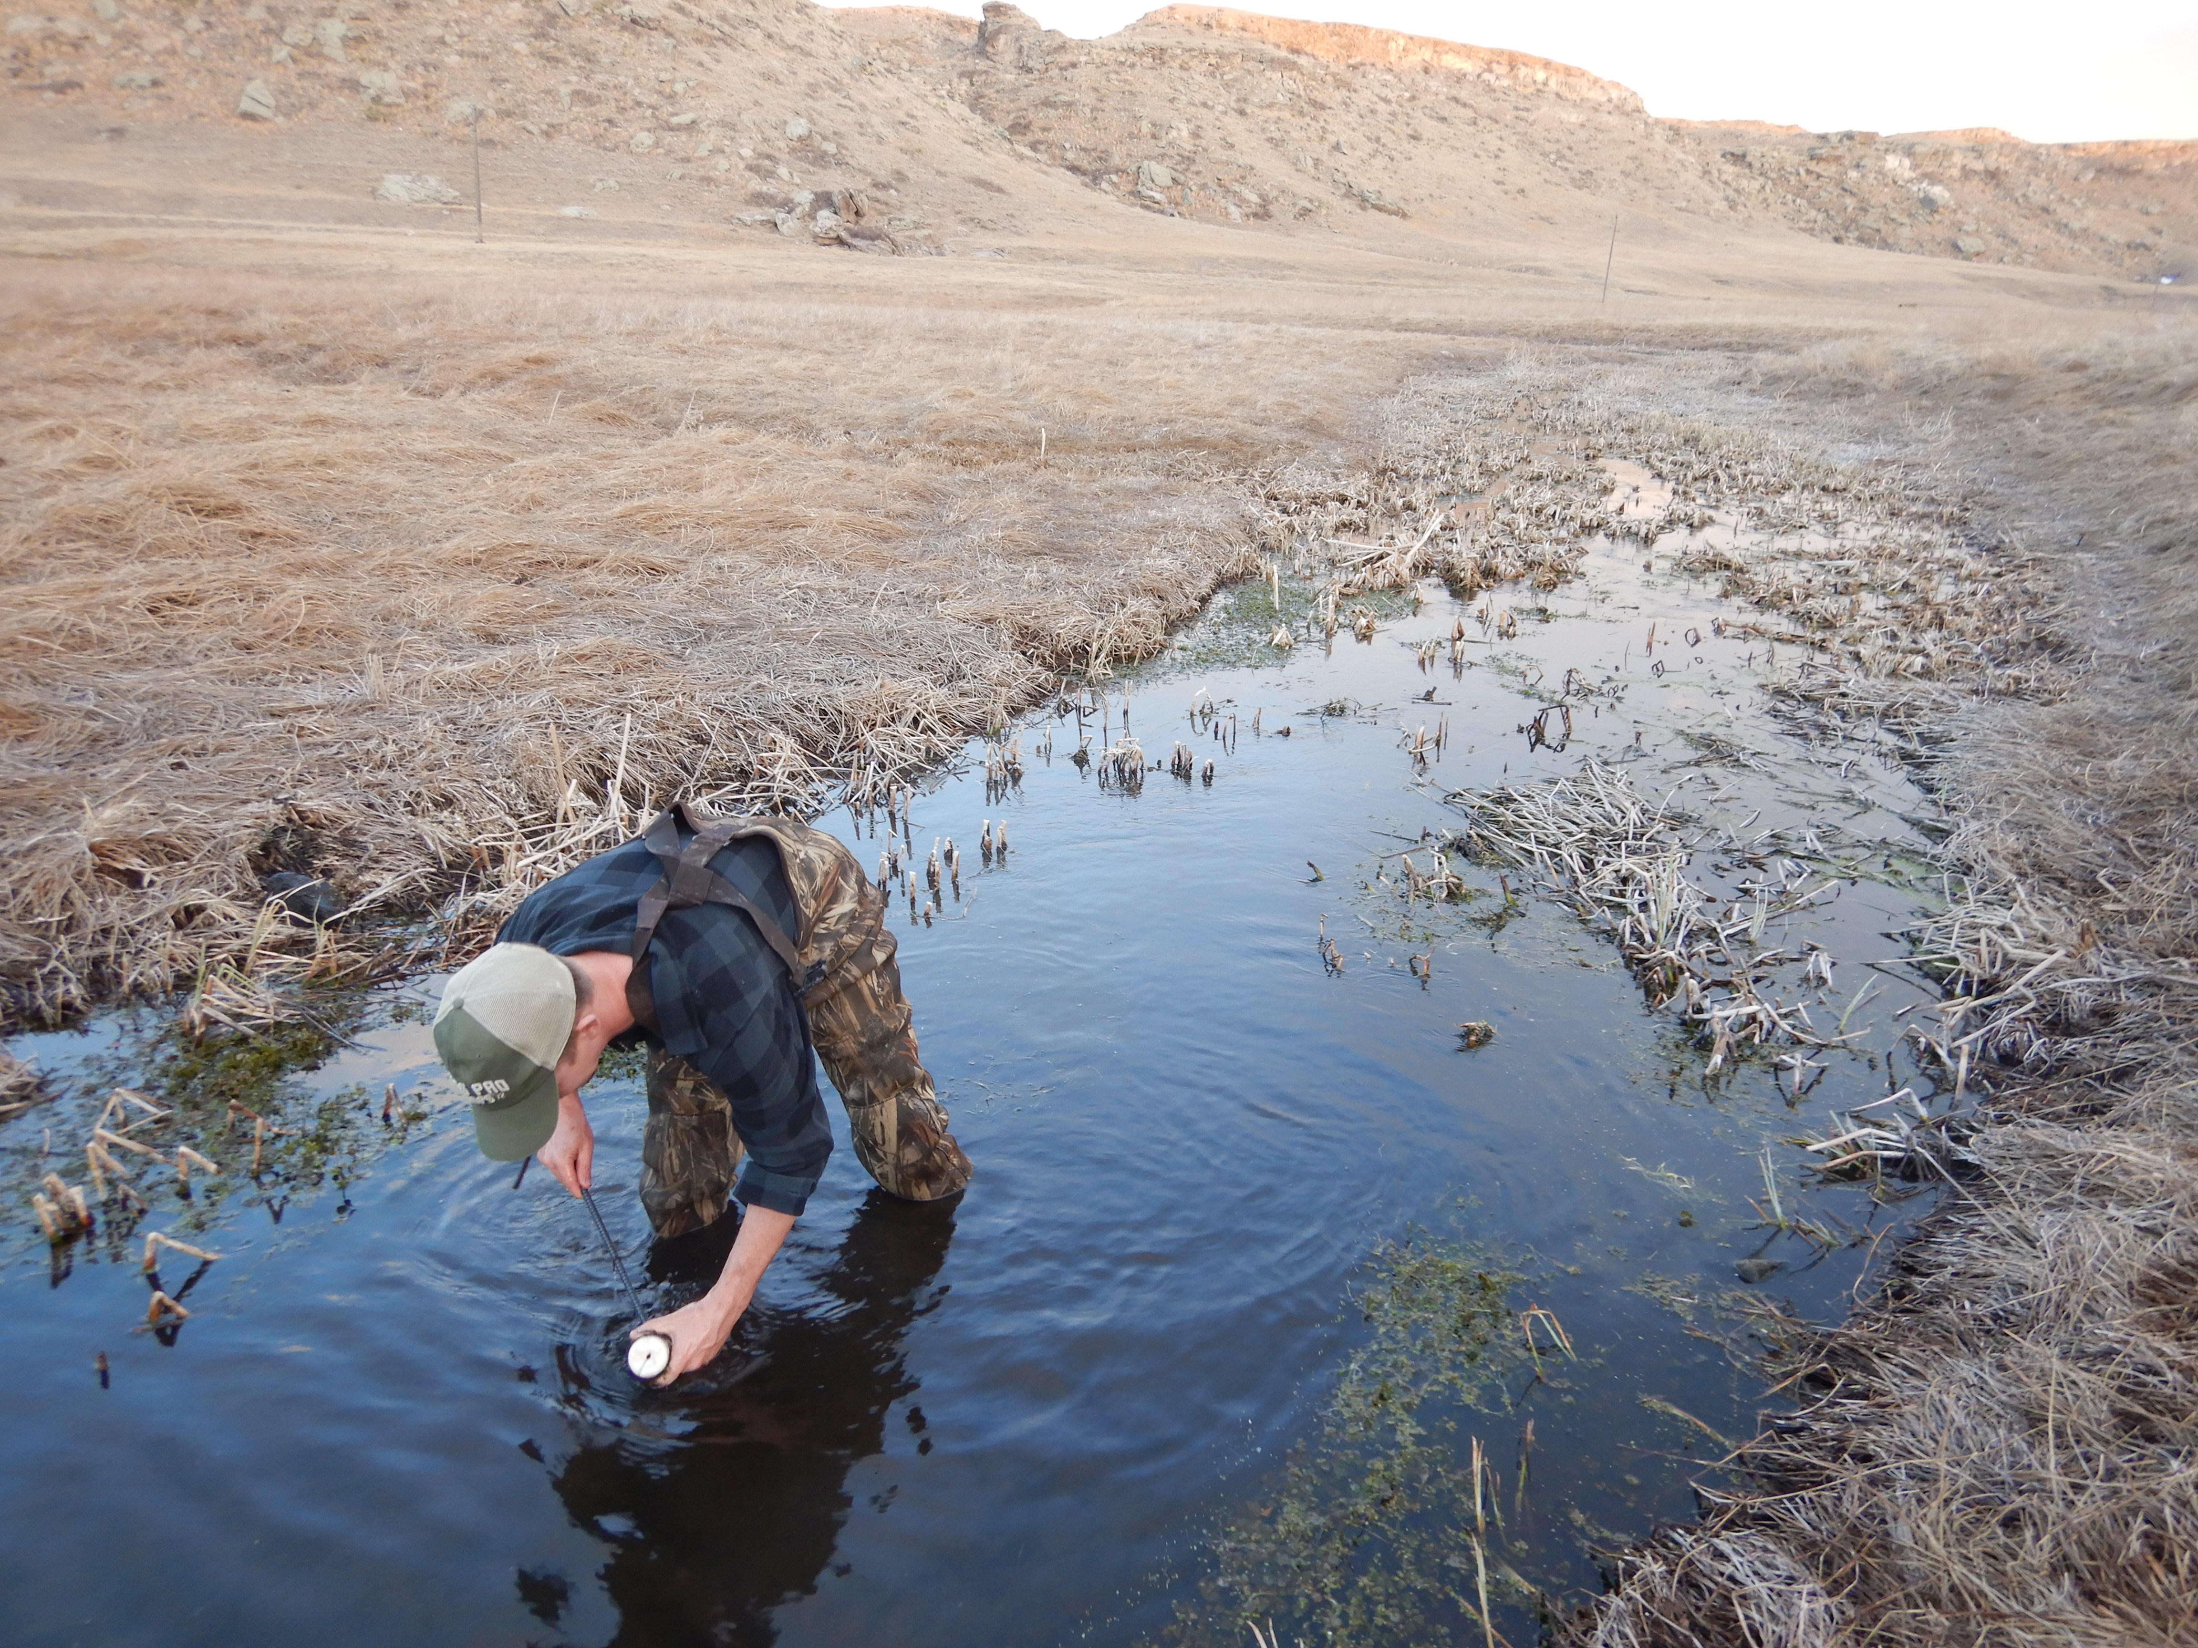

Long Pine – Pine Glen WMA – lost, replaced 6/10/20

Placed right of tree when looking from parking area/service road. 2 ft to right of tree

42.67913, 099.69636 #208

Bordeaux Creek – Cliffs lost and replaced

Placed below culvert, left bank facing downstream. #284

42.71781, -102.93041

Sowbelly Creek – Coffee Park Placed on 6-24-2020

Placed at first fence crossing below parking lot. Right bank looking downstream, below trees, placed rocks over casing. GPS #299 42.73421 , -103.84023

Monroe – 6-24-2020 found and reset 6-24-20

Same place, pool right bank looking downstream .

Soldier Creek, middle branch. – 6/24/20 lost and replaced, may be worth another look at old location

Park at picnic tables and walk upstream. Right side looking upstream, clipped to a small tree on right shoreline looking upstream.

#305, 42.69785, -103.56797

Holt Creek WMA pulled on 7-8-20

Roberg said don’t redeploy